Output screenshot of Assignment 3

select * from Department

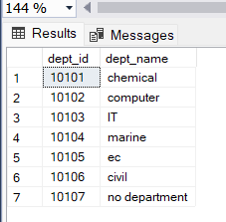

select * from Employee

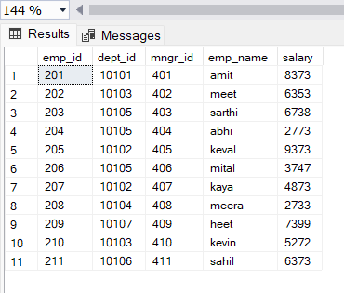

Output of query1:

write a SQL query to find Employees who have the biggest salary in their Department

select D.dept_name,E.emp_name,E.salary

from Department D

inner join Employee E

on E.dept_id=D.dept_id

where E.salary in

(select MAX(salary) from Employee group by dept_id)

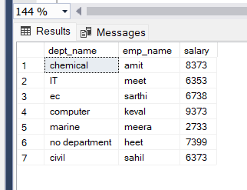

Output of query2:

write a SQL query to find Departments that have less than 3 people in it

select dept_name

from Department

inner join Employee

on Employee.dept_id=Department.dept_id

group by dept_name

having COUNT(emp_id)<3

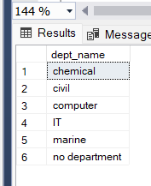

Output of query3:

write a SQL query to find All Department along with the number of people there

select D.dept_name as "Department Name",COUNT(E.emp_id) as "No. of Employee"

from Department D

inner join Employee E

on E.dept_id=D.dept_id

group by D.dept_name

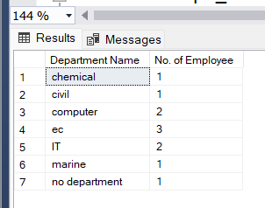

Output of query4:

write a SQL query to find All Department along with the total salary there

select D.dept_name as "Department Name",SUM(E.salary) as "total salary"

from Department D

inner join Employee E

on E.dept_id=D.dept_id

group by D.dept_name

